IPSO-EUROPE offers a Webinar providing an important opportunity for the intercultural dialogue between candidates in the pluralistic European psychoanalytical landscape.
23rd
-
Jan.
-
2021
If you are interested, please e-mail Liliana Castro, IPSO rep in Porto at
Meet the Analyst

  - 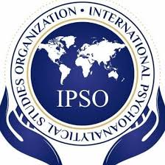
  - Monica Bomba & Jeremy Freeman
  - IPSO – EUROPE
  - IPSO-Europe@ipso-candidates.org.uk
  - Webinar
23-January-2021

Meet the Analyst

The Infantile in the analytic work
IPSOwebinar@gmail.com

Dialogue with Florence Guignard
Florence Guignard was born in Geneva, where she completed her studies in clinical psychology, then her psychoanalytical studies at the Swiss Psychoanalytical Society, while directing research for the Swiss National Science Foundation. She settled in Paris in 1970 and worked there for 43 years as a psychoanalyst for children, adolescents and adults, before retiring to Switzerland in 2013.
Actively involved in the teaching and training of psychoanalysts, Florence Guignard is a direct member of the International Psychoanalytical Association, of which she has directed the Committee for Child and Adolescent Psychoanalysis and co-facilitated the Committee for integrated adult/child training. With Annie Anzieu, she created, in 1984, the Association pour la psychanalyse de l’enfant (APE), and then, in 1994, the Société européenne pour la psychanalyse de l’enfant et de l’adolescent (SEPEA), which she chaired on several occasions.
She is a member of the editorial board of the journal L’Année psychanalytique internationale, of which she was editor-in-chief until 2010. In addition, she has twice served as Vice-President of the Psychoanalytical Society of Paris. With numerous books written in collaboration and more than 250 published articles, she is also the author of two books: Au vif de l'Infantile (1996), Épître à l'objet (1997).
To find more about Florence Guignard you can check her website:https://www.florenceguignard.com/.

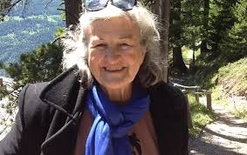

REGISTER NOW
https://us02web.zoom.us/meeting/register/tZAofu-vqT8pE9XkSECgPrk8aR85qZ7phObv
New York 5am Buenos Aires 7am
London 10am Tokyo 7pm Sydney 9pm
This webinar (lasting 2 hours) is for attendance by IPSO members only
and will be conducted using the Zoom meeting format, with participant
cameras on. The Zoom link will be forwarded following registration
Registrations close on 16 January
A large part of this session will be a discussion of the topic of working
the infantile in the psychoanalytic setting. Recording is not allowed.

